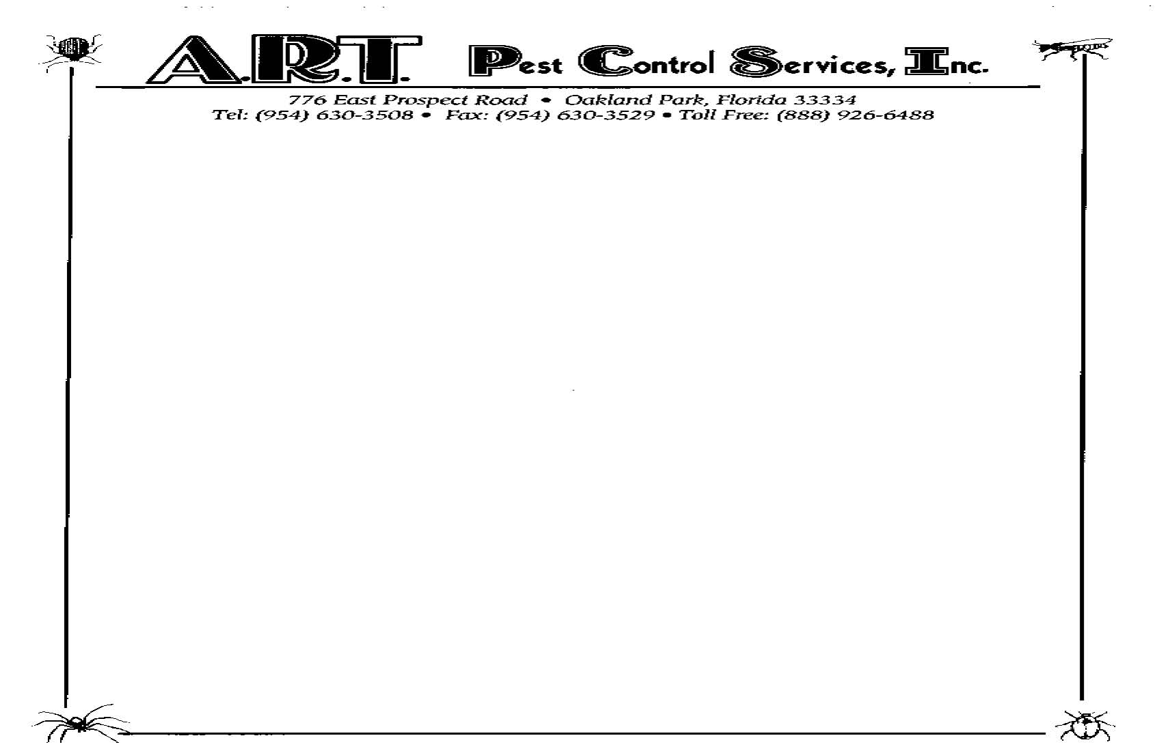
Non-Service Request

Non Service Request
Property Name:
Service Location:
Manager: ____________________________ Telephone No.: _____________________

Unit | Request Date | Comments

